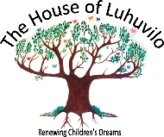
GIFT AID
The House of Luhuvilo Registered Charity No. 1175276
I wish Gift Aid to apply to the enclosed donation. I am a UK taxpayer and understand that if I pay less Income tax and/or Capital Gains Tax than the amount of Gift Aid claimed on all my donations in that tax year it is my responsibility to pay any difference.

Please print clearly.
Full Name……………………………………………………………………..

House No/Name……………………………………………………………

Postcode…………………………………………..Date…………………..

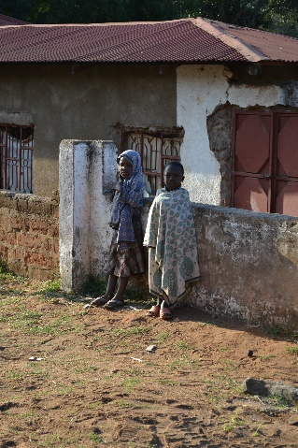
From Nicky, Linda, David, Emma and Bev and all the children thank you for your support and prayers. For more information please visit www.thehouseofluhuvilo.com email njteverson@gmail.com
To purchase the following, in aid of raising funds for the children and providing income for local Tanzanian people, please complete the form below and post to:
Nicky Teverson, Director of ‘The House of Luhuvilo, 16, Sandy Lane, Sevenoaks, Kent, TN13 3TP enclosing a cheque made payable to ‘The House of Luhuvilo’.
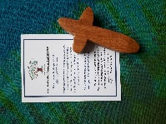
Wooden Holding Cross hand made by local Tanzanian carpenters. Size approximately L:10cm W:5cm£5.00 plus postage of £1.00
Wooden Heart hand made by local Tanzanian carpenters. Size approximately L:5cm W:6cm£5.00 plus postage of £1.00
Product……………………………………Quantity…………Product……………………………………Quantity…………Name………………………………………………………………Address ………….……………………………………………..
……………………………………………………………………….
Telephone number…………………………………………
Email ……………………………………………………………..
I enclose a cheque for…………………………………….
By signing this I agree to the charity of The House of Luhuvilo keeping my private details confidential and to any correspondence necessary form order. …………………………………………………………………….
(Please sign)
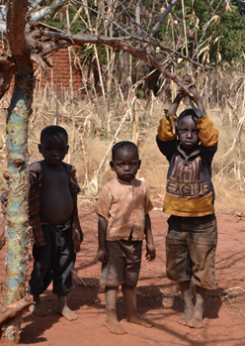
Registered Charity 1175276
www.thehouseofluhuvilo.com
The House of Luhuvilo is a charity set up to provide a safe home and life-giving futures for orphaned children in Tanzania.
The most vulnerable children are rejected by the family and are called ‘roaming children’ or ‘street children’.It is these children that The House of Luhuvilo aims to reach.

The House of Luhuvilo, which means HOPE, is being built in the mountains of Sayuni in Njombe, Tanzania.
Our Vision is to create a beautiful home for children, that allows them to heal from the traumas of their past and give them a childhood rooted in security, safety and nurture. Child protection and safe guarding is our priority.
Read on for Update: September 2018
Progress so far:
- Since becoming a charity in October 2017, we have raised £50,000, which means we were able to start the building of the first cottage in May 2018 and hopefully will welcome our first children by September 2019.
- Two Novices from the convent are being trained in Dodoma in childcare.
- Nicky and David will be visiting Njombe in October 2018 to assess the progress of the build, make plans for the energy supply and meet with Social Welfare to continue the necessary regulative rigour.
Cottage Plan

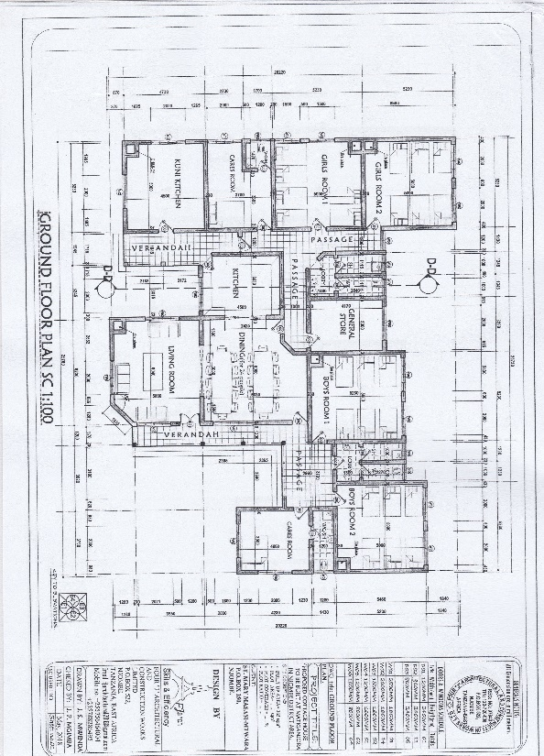
.
Foundations begin -May 2018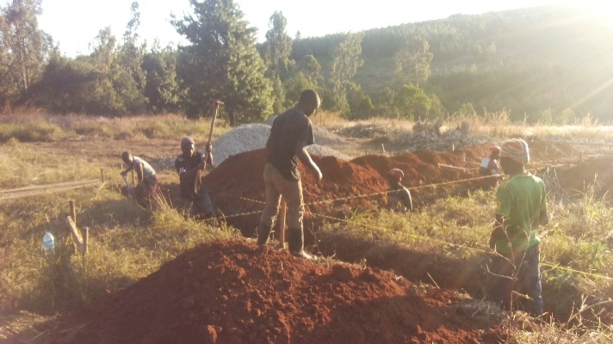
Walls and window frames- July 2018
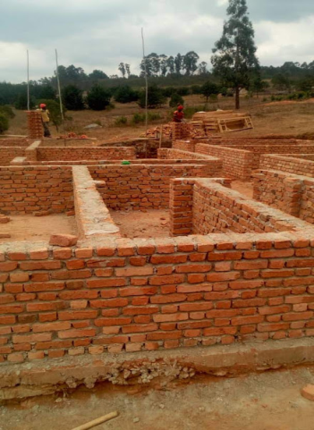
We are currently building our first cottage for 24 children, alongside the manager’s accommodation.
Next….
The next stage is to provide
- a playground = £2,500
- kindergarten = £18,000
- second cottage = £45,000

To commence soon……
Sponsor a Child, who, you alone will support in providing food, clothes and education. You will be invited to send cards and small gifts and in return we will send you pictures and letters from your child.

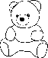
Donate money to make welcome packs for children, who will arrive from the street at The House of Luhuvilo with have nothing. This gift will be available with a special thank you certificate for purchase in November via the website and post.
If you would like to monitor our progress via a monthly newsletter please email Nicky on njteverson@gmail.com
To Donate - If you would like to donate to the charity as a one-off donation or a monthly standing order the bank details are: Account number: 63946754 SORT CODE 20-18-93
Name: THE HOUSE OF LUHUVILO Charity No. 1175276
Every penny you donate will be spent on The House of Luhuvilo.

